**Assignment no :- 02**

AGILE METHODOLOGY : JIRA TOOL

Create the project for any web application example using agile methodology (SCRUM

TEMPLATE).

(6 ISSUES)>>>>>>; 4 STORY , 1 TASK, BUG

Name of project : **TravelManagementSystem**

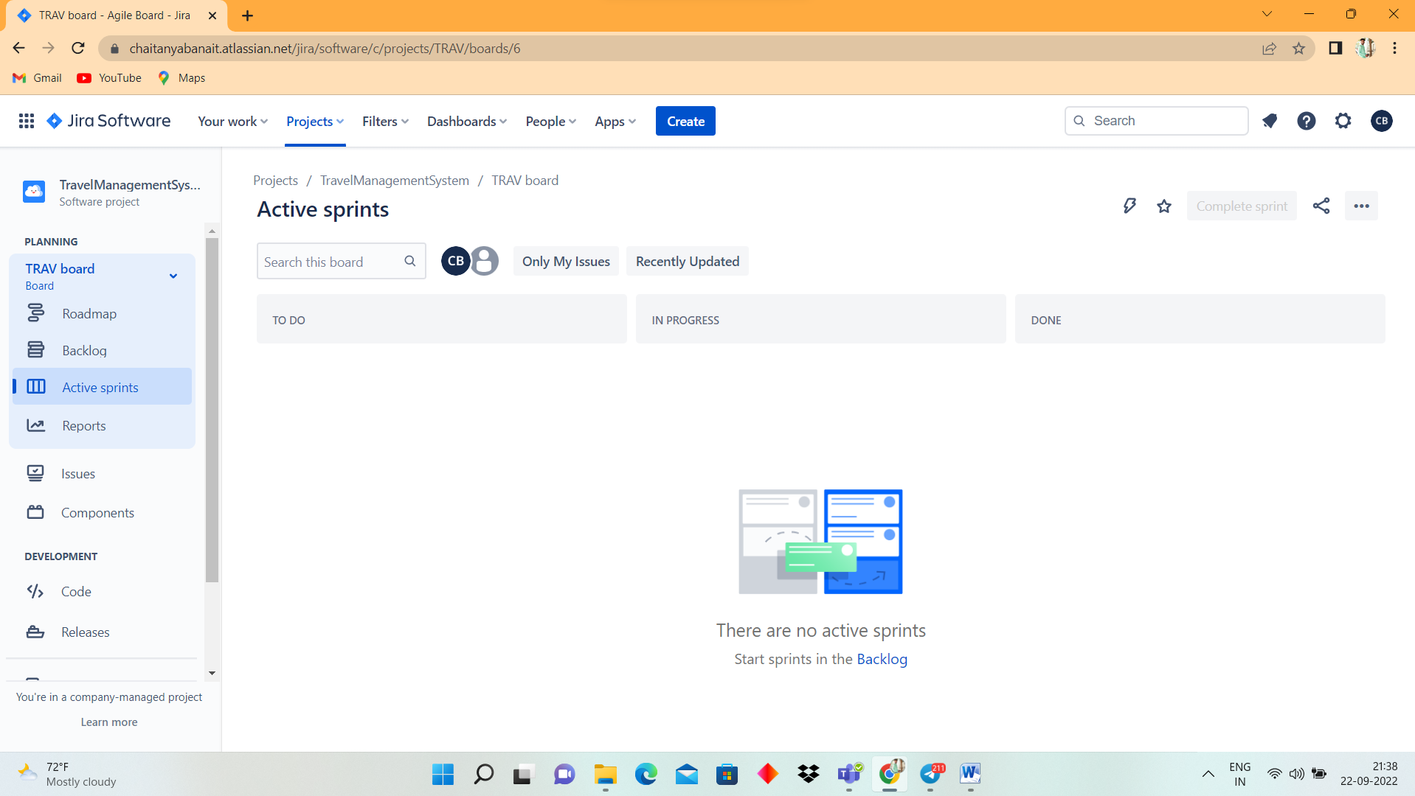

**Create Component**

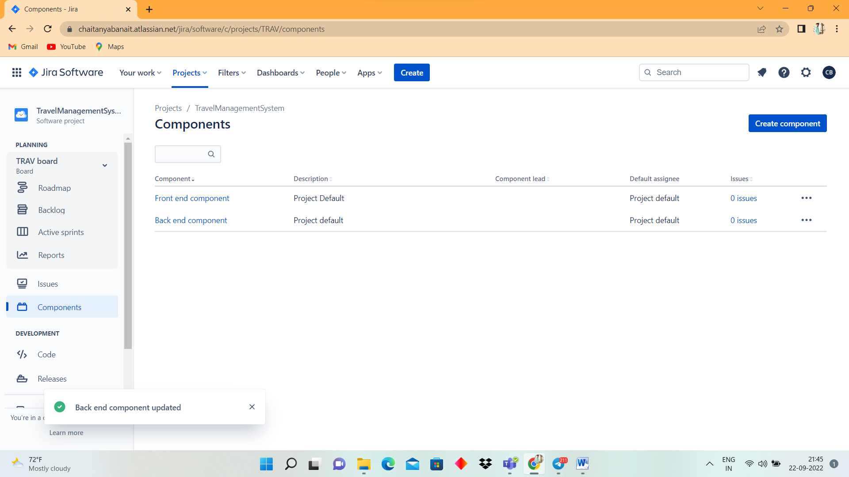

**Plan the version with release dates**

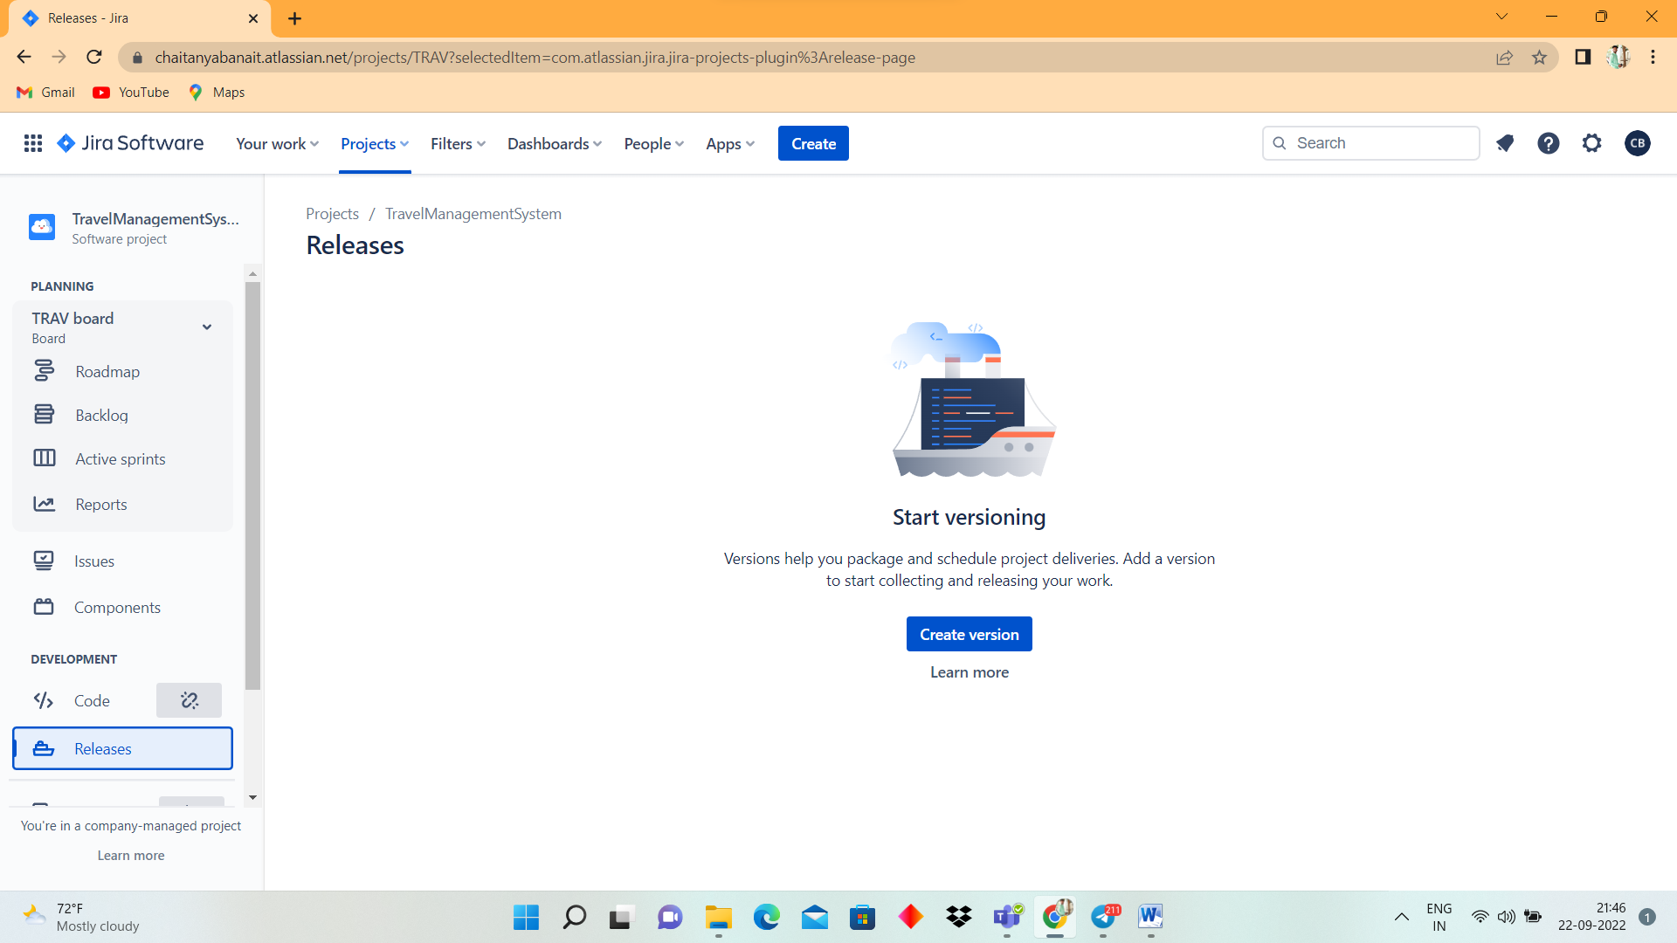

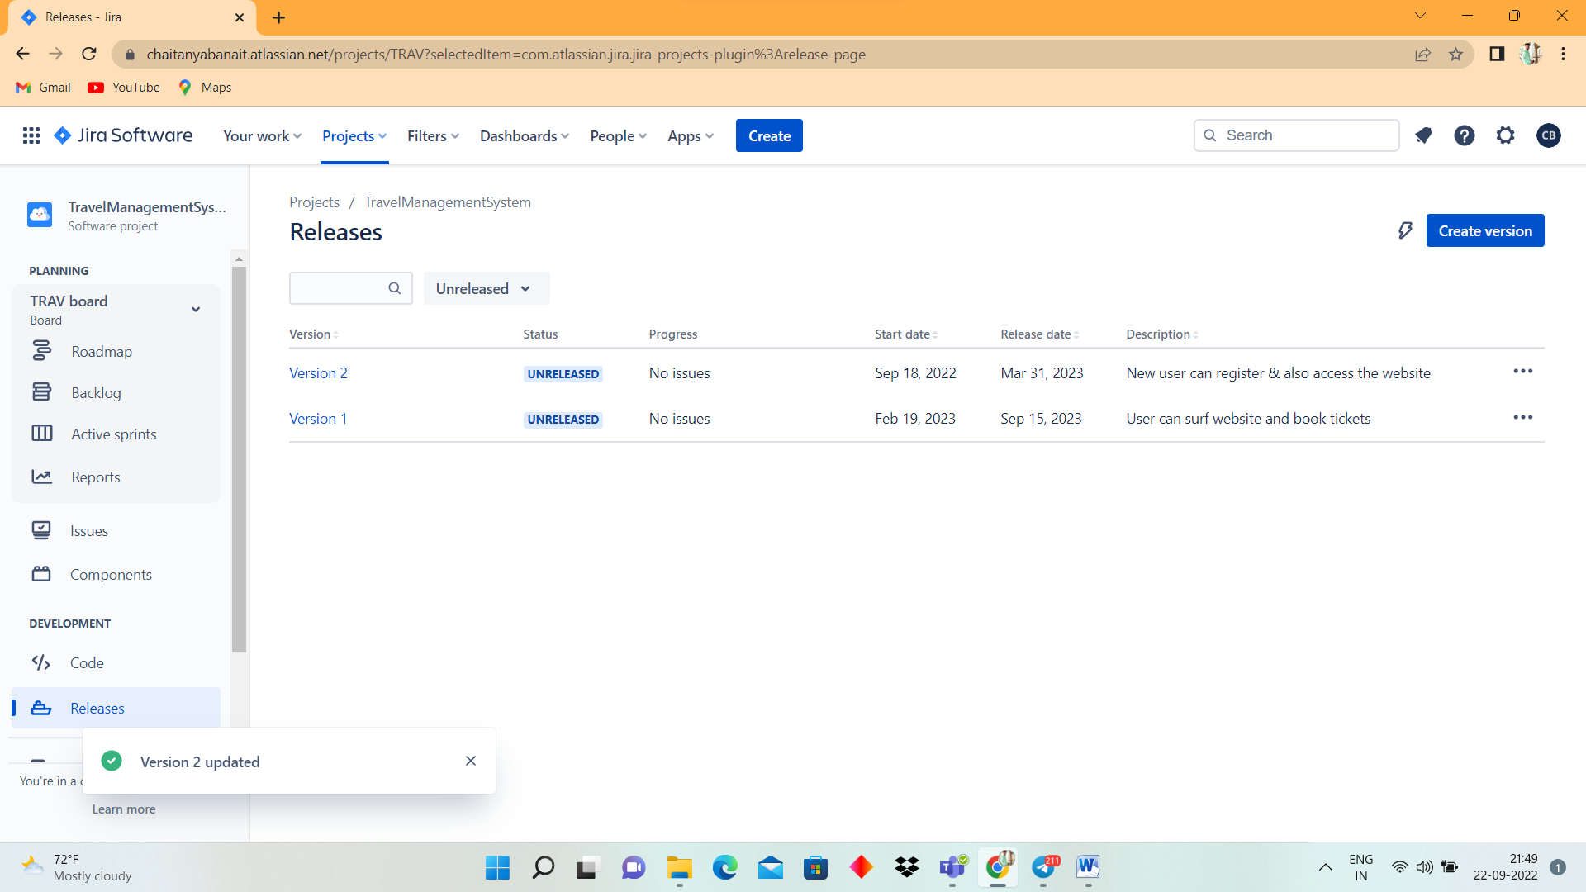

**Create sprint backlog, start sprint and complete sprint**

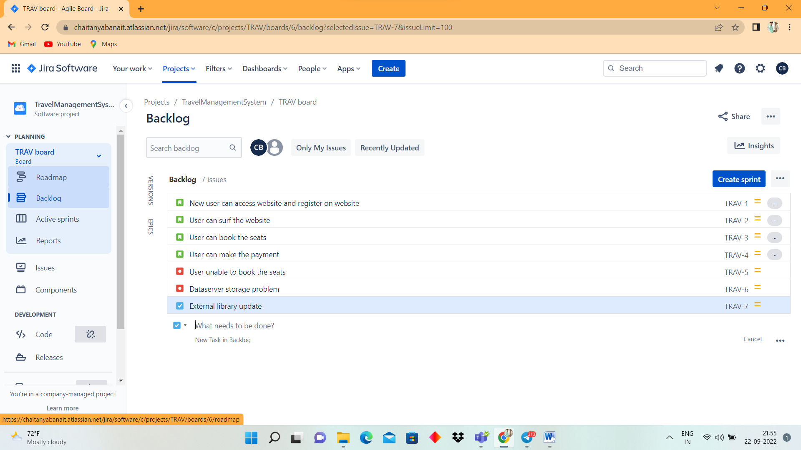

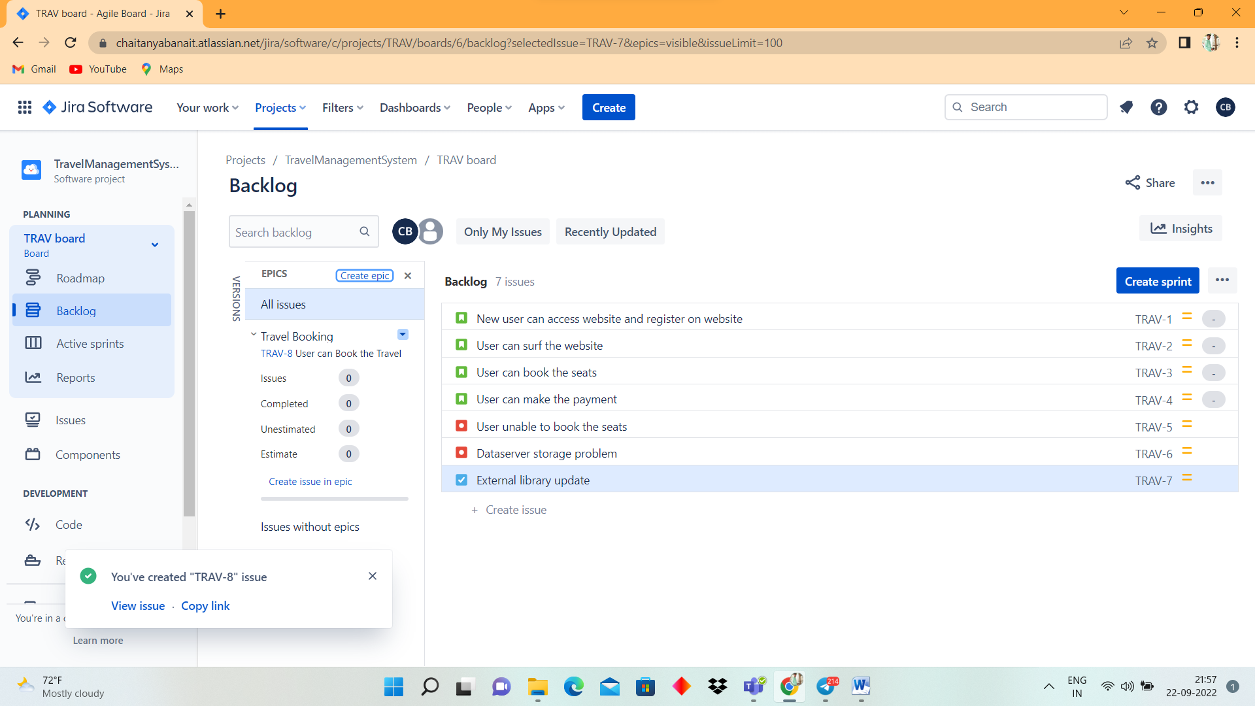

**Create different types of issues in the backlog.-Epic –provide epic link also**

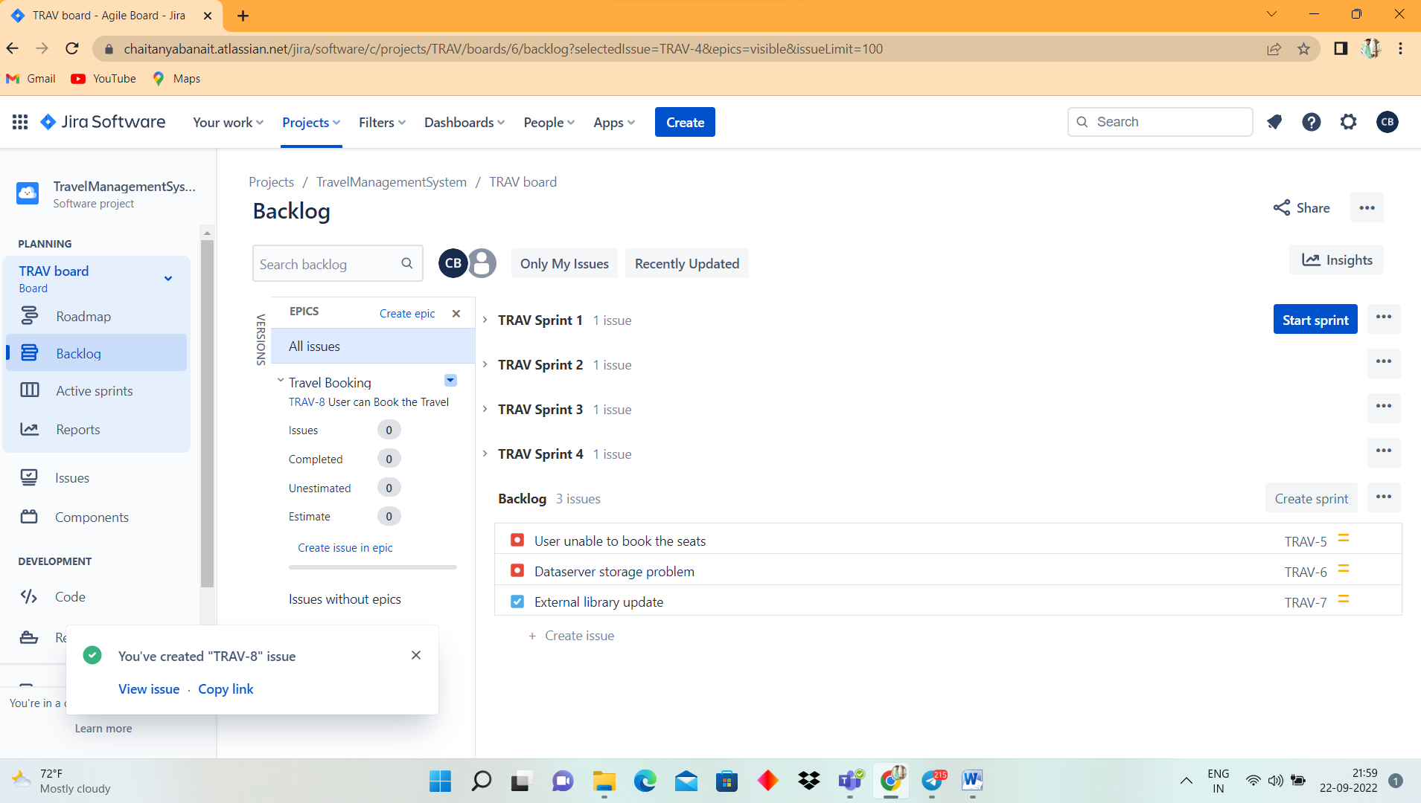

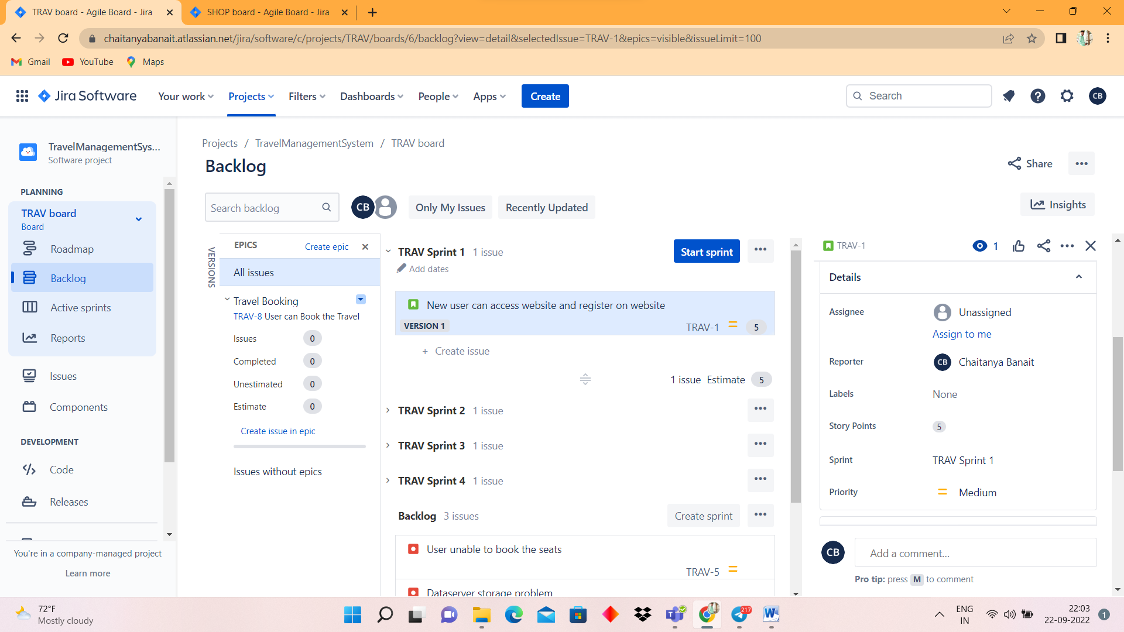

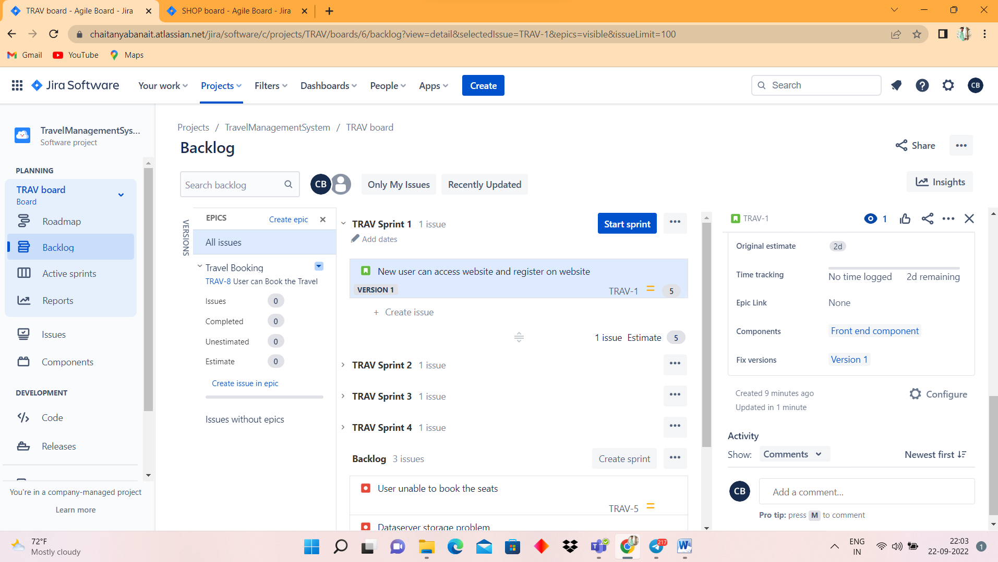

**Divide into sub-tasks**

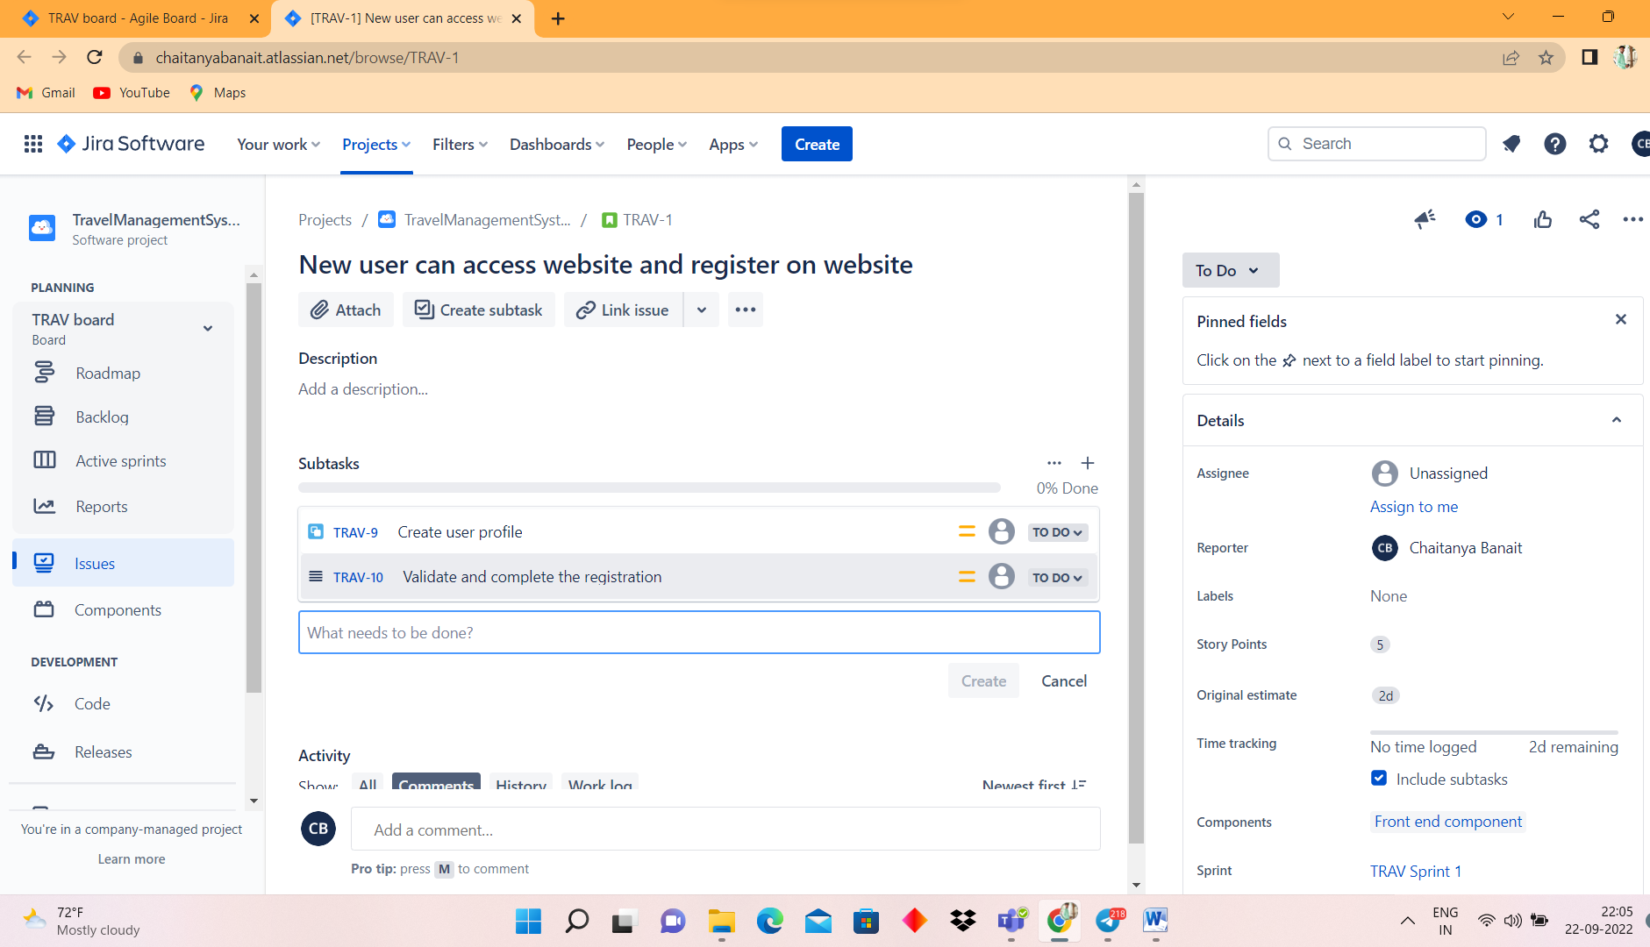

**Give estimate time**

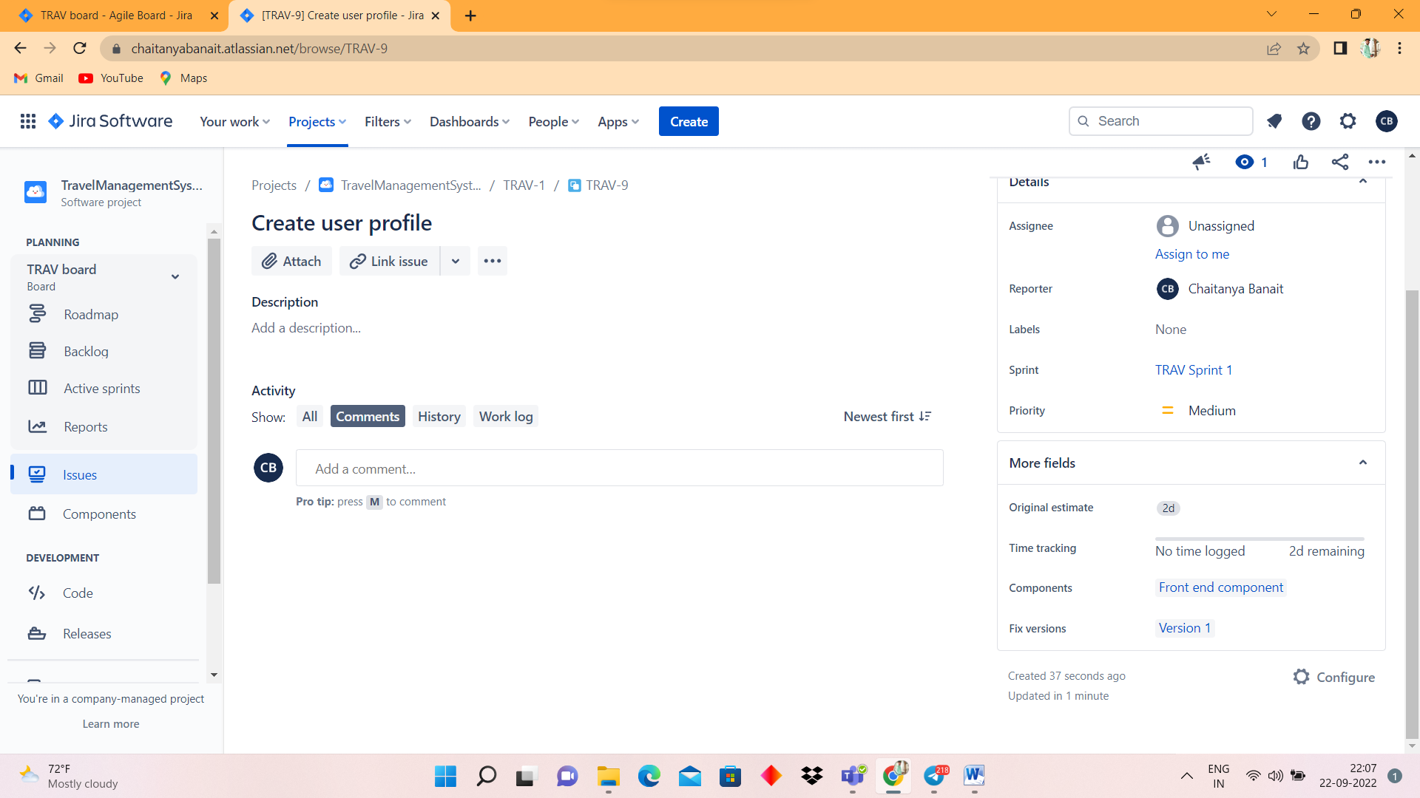

-**task**

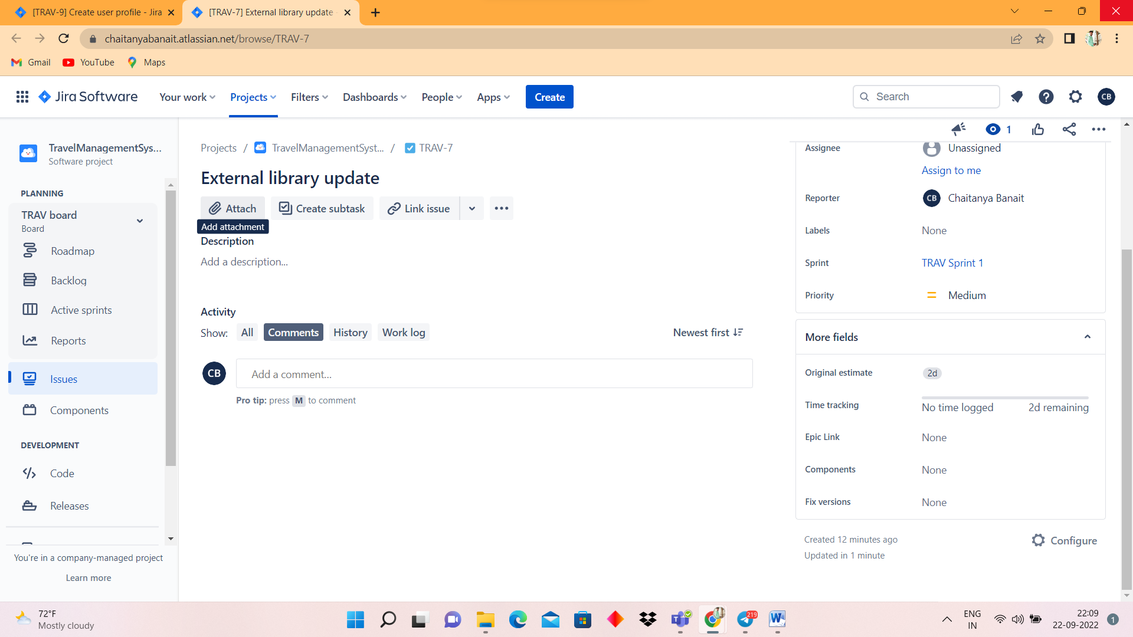

**Bug**

